

GAUTENG DEPARTMENT OF EDUCATION
PREPARATORY EXAMINATION
2016
10842
PHYSICAL SCIENCES: CHEMISTRY
SECOND PAPER

TIME: | 3 hours
MARKS: | 150

17 pages + 4 information sheets

GAUTENG DEPARTMENT OF EDUCATION
PREPARATORY EXAMINATION – 2016

PHYSICAL SCIENCES
(Second Paper)

TIME: 3 hours

MARKS: 150

INSTRUCTIONS AND INFORMATION:

1. | Write your name in the appropriate space on the ANSWER BOOK.
2. | This question paper consists of 11 questions. Answer ALL the questions in the ANSWER BOOK.
3. | Start the answer to each question on a NEW page.
4. | Number the answers correctly according to the numbering system used in this question paper.
5. | Leave ONE line open between sub-questions, for example, between QUESTION 2.1 and QUESTION 2.2.
6. | You may use a non-programmable calculator.
7. | You may use appropriate mathematical instruments.
8. | You are advised to use the attached DATA SHEETS.
9. | Show ALL formulae and substitutions in ALL calculations.
10. | Round off your final numerical answers to a minimum of TWO decimal places.
11. | Give brief discussions, et cetera where required.
12 | Write neatly and legibly.

QUESTION 1: MULTIPLE-CHOICE QUESTIONS
Four options are given as possible answers to the following questions. Each question has only ONE correct answer. Write only the letter (A–D) next to the question number (1.1–1.10) in the ANSWER BOOK.

1.1 | Which ONE of the following is the functional group of the carboxylic acids?
 | A | C  C | B | O  H
 | C | C  C | D | C  O  O  H | (2)

1.2 | Consider the reaction represented below:  HCℓO₂ + H₂O ⇌ H₃O⁺ + CℓO  Which ONE of the following is a conjugate acid-base pair in the above reaction?
 | A | HCℓO₂ and CℓO
 | B | HCℓO₂ and H₂O
 | C | CℓO and H₃O⁺
 | D | HCℓO₂ and H₃O⁺ | (2)

1.3 | Which ONE of the following compounds has the highest boiling point?
 | A  B  C  D | CH3CH3  CH3CH2CH3  CH3CH2CH2CH3  CH3CH2CH2CH2CH3 | (2)

1.4 | A learner leaves a coil of copper wire overnight in a clear solution of silver nitrate. The next morning the learner observes that the solution turned blue. Which ONE of the equations below represents the reaction that takes place?
 | A  B  C  D | Cu + Ag⁺ → Cu⁺ + Ag  2Ag + Cu²⁺ → Cu + 2Ag⁺  2Ag⁺ + Cu⁺ → 2Ag + Cu²⁺  Cu + 2Ag⁺ → Cu²⁺ + 2Ag | (2)
1.5 | The half-reactions below take place in an electrochemical cell.  Pt²⁺ + 2e⁻ → Pt  Cs⁺ + e⁻ → Cs  Which ONE of the statements below is TRUE for this cell when it delivers current?
 | A  B  C  D | The mass of the Cs electrode increases.  Pt²⁺ undergoes oxidation more easily than Cs.  Pt²⁺ undergoes reduction more easily than Cs⁺.  Electrons will flow from the Pt electrode to the Cs electrode in the external circuit. | (2)
1.6 | Two reactions, X and Y, represented below reach equilibrium in two separate, sealed containers.  Reaction X: 2HI(g) ⇌ H₂(g) + I₂(g)  Reaction Y: CaCO₃(s) ⇌ CaO(s) + CO₂(g)  The pressure in both containers is increased by decreasing the volume of the container. How will the number of moles of the products in each container change?

 |  | X | Y
 | A  B  C  D | Increases  Stays the same  Stays the same  Increases | Decreases  Increases  Decreases  Stays the same |  |  | (2)

1.7 | Carbon monoxide, CO(g), and hydrogen, H₂(g), react in a closed container to form methanol, CH₃OH(g), according to the following balanced equation:  CO(g) + 2H₂(g) ⇌ CH₃OH(g)  The graph below shows the change in concentration of methanol with time.  Time (s)  Concentration  (mol·dm⁻³)  t  Which ONE of the following statements, best explains the horizontal section of the graph after time t?
 | A  B  C  D |  | The forward reaction has stopped.  The rates of the forward and reverse reactions are equal.  There is no CO(g) left to react with the H₂(g).  All the reacting gases have been converted to methanol. |  | (2)
1.8 | When base X is titrated against acid Y, the pH of the solution at the end point is 8. Which ONE of the following represents base X and acid Y?
 |  | A  B  C  D |  | (2)
  X | Y
  NaOH | CH₃COOH
  Na₂CO₃ | HCℓ
  NaOH | H₂SO₄
  Na₂CO₃ | CH₃COOH

1.9 | Two of the half-reactions below take place in a standard electrochemical cell with an emf of 1,2 V.  R⁺ + e⁻ ⇌ R E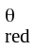 = - 1,5 V  P²⁺ + 2e⁻ ⇌ P E = - 0,3 V  Q⁺ + e⁻ ⇌ Q E = - 0,9 V  S²⁺ + 2e⁻ ⇌ S E = + 1,5 V  The cell notation of this cell is:
 |  | A  B  C  D |  | S(s)∣S²⁺(aq)∣∣P²⁺(aq)∣P(s)  P(s)∣P²⁺(aq)∣∣Q⁺(aq)∣Q(s)  R(s)∣R⁺(aq)∣∣S²⁺(aq)∣S(s)  R(s)∣R⁺(aq)∣∣P²⁺(aq) ∣ (s) |  | (2)
1.10 |  | The graph below shows the relationship between the amount of substance and time in a chemical reaction involving substances K, L and M.  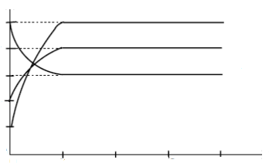  0 10 20 30 40  Time (s)  1  0  2  3  4  5  Amount of substance  (mol)  K  L  M  The equation for the reaction can be represented as:
 |  | A |  | 3M → 4K + 5L
 |  | B |  | 5M → 2K + L
 |  | C |  | M → 2K + L
 |  | D |  | M → K + 2L |  |  | (2)
 |  |  |  |  | [20]

QUESTION 2
2.1 | Consider the structural formula of an organic compound below.
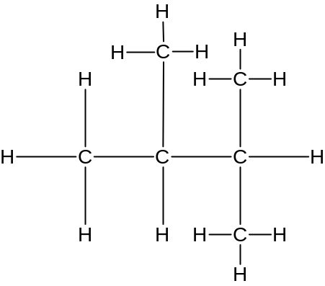

 | 2.1.1 |  | Is the above compound a SATURATED or an UNSATURATED hydrocarbon? Give a reason for the answer. | (2)
 | 2.1.2 |  | Write down the IUPAC name of the above compound. | (2)
2.2 | Draw the structural formula of 4,4-dimethylhexan-2-one. |  |  | (3)
2.3 | In industry ethene is used to synthesise a variety of organic compounds. The flow diagram below illustrates some of the reactions that ethene can undergo.  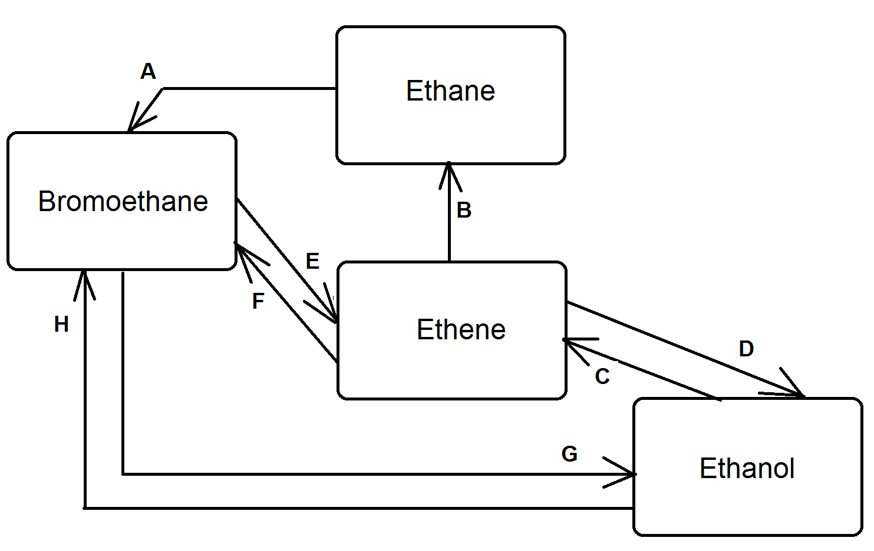
 | 2.3.1 | Write down:  The general formula of the homologous series to which ethene belongs. |  | (1)
 | 2.3.2 | A balanced equation, using structural formulae, for reaction B. |  | (3)
 | 2.3.3 | The type of reaction represented by G. |  | (1)
 | 2.3.4 | The FORMULA of the inorganic reactant needed for reaction F. |  | (1)
 | 2.3.5 | The letter that represents a dehydrohalogenation reaction. |  | (1)
 | 2.3.6 | How the base used in reaction E differs from the base used in reaction G. |  | (1)
 | 2.3.7 | The NAME or FORMULA of the catalyst used in reaction C. |  | (1)
[16]

QUESTION 3
3.1 | Write down the name of the homologous series to which each of the following compounds belongs:
 | 3.1.1 | CH₃CHO | (1)
 | 3.1.2 | CH₃COCH₃ | (1)
3.2 | 3.2.1 | Define the term positional isomer. | (2)
 | 3.2.2 | Write down the structural formula of an isomer of 1-chloropropane. | (2)
3.3 | The compound responsible for a fruity scent, pentyl butanoate, is prepared in the laboratory.  Write down the:
 | 3.3.1 | IUPAC names of TWO compounds needed for this preparation. | (2)
 | 3.3.2 | Type of reaction that takes place. | (1)
3.4 | Consider the structural formula of a polymer shown below.
C
C
C
C
C
C
C
C
C
H
H
H
H
H
H
H
H
H
H
H
H
H
H
H
H
H
H

Write down the:

 | 3.4.1 | IUPAC name of this polymer. | (1)
 | 3.4.2 | Structural formula of the monomer used to prepare this polymer. | (1)
 | 3.4.3 | Type of polymer of which it is an example. | (1)
[12]

QUESTION 4
The table below shows data collected for four organic compounds during two practical investigations. The compounds are represented by the letters A, B, C and D. The boiling point of compound B is unknown and recorded as X.

Investigation | Organic compound |  | Relative molecular mass | Boiling point (˚C)
I | A | CH₃CH₂CH₂CH₂CH₃ | 72,15 | 36,1
I | B | CH₃CH(CH₃)CH₂CH₃ | 72,15 | X
II | C | CH₃CH₂CH₂CH₂OH | 74,12 | 117
II | D | CH₃CH₂COOH | 74,08 | 141,2

4.1 | For investigation II, write down the:
 | 4.1.1 | Dependent variable. | (1)
 | 4.1.2 | Independent variable. | (1)
 | 4.1.3 | Controlled variable | (1)
4.2 | Will the boiling point of compound B, be HIGHER THAN, LOWER THAN or EQUAL TO the boiling point of compound A? |  | (1)
4.3 | Fully explain the answer to QUESTION 4.2. |  | (3)
4.4 | How will the vapour pressure of compound C compare to that of compound D? Choose from HIGHER THAN, LOWER THAN or EQUAL TO. |  | (1)
4.5 | Fully explain the answer to QUESTION 4.4 |  | (3)
4.6 | Write down the STRUCTURAL FORMULA and IUPAC NAME of a FUNCTIONAL isomer of compound D. |  | (4)
[15]
QUESTION 5
A group of learners use the reaction between magnesium and nitric acid to investigate one of the factors that affects reaction rate. The reaction that takes place is represented by the balanced equation below.

Mg(s) + 2HNO₃(aq) → Mg(NO₃)₂(aq) + H₂(g)

They add magnesium ribbon to dilute nitric acid and measure the mass of magnesium used per unit time. The experiment is repeated using concentrated nitric acid.

5.1 | Write down an investigative question for this investigation. | (2)
 | The results obtained for the reaction with dilute nitric acid are represented in the graph below:
Amount of magnesium
(mol)
0 30
0,8
1,0

Time (s)

5.2 | Which substance, Mg or HNO₃, is in excess? Use the information on the graph to give a reason for the answer. | (2)
5.3 | Define the term reaction rate. | (2)
5.4 | Calculate the average rate of the reaction (in gram per second) during the first 30 s. | (5)
5.5 | Copy the above graph in your answer book. On the same set of axes use a DOTTED LINE to show the curve that will be obtained when concentrated nitric acid is used. No numerical values are required. | (2)
[13]
QUESTION 6
6.1 | Curve L shown below, is the Maxwell-Boltzman distribution curve for a gas in a closed container at 250 °C.
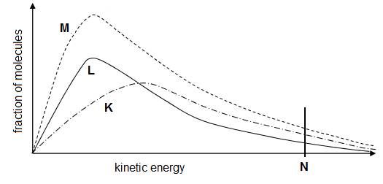
Fraction of molecules
Kinetic energy

 | 6.1.1 | Name the energy represented by N. | (1)
 | 6.1.2 | Write down the change in reaction conditions that resulted in:  (a) Curve M. | (1)
 |  | (b) Curve K.  Use the collision theory to explain how this change affects the rate of the reaction. | (4)

6.2 | A series of experiments are carried out to compare the reactions of zinc foil, zinc powder, copper powder and a mixture of zinc powder and copper pieces with dilute sulfuric acid of concentration 1 mol·dm⁻³. Hydrogen gas is produced in all test tubes where a reaction takes place. The diagram shows the test tubes some time after the metals have been added to the acid.
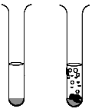
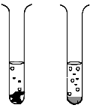
H₂SO₄(aq)
B
A
C
D
H₂SO₄(aq)
Zn foil
Zn powder
Cu powder
Zn powder
+
Cu pieces

 | 6.2.1 | Refer to the relative strengths of oxidizing agents or reducing agents to explain why no reaction takes place in test tube C. | (3)
 | 6.2.2 | How does the rate of the reaction in test tube B compare to that in:  (Choose from GREATER THAN, SMALLER THAN or EQUAL TO.)
 |  | - Test tube A?  Give a reason for your answer. | (2)
 |  | - Test tube D?  Give a reason for your answer. | (2)
[13]
QUESTION 7
7.1 | The reaction represented below reaches equilibrium in a closed container.  4C(s) + 5H₂(g) ⇌ C₄H₁₀(g)  The equilibrium constants for this reaction at two different temperatures are given in the table below.
  TEMPERATURE (K) | EQUILIBRIUM CONSTANT (K_{c})
  400 | 1,58 x 10⁻³
  600 | 1,58 x 10⁻⁹
 | 7.1.1 | Is the forward reaction ENDOTHERMIC or EXOTHERMIC? | (1)
 | 7.1.2 | Use Le Chatelier’s principle to explain your answer in QUESTION 7.1.1. | (3)
 | 7.1.3 | The pressure in the container is now decreased by increasing the volume of the container. What effect will this have on the value of the equilibrium constant?  Choose from INCREASES, DECREASES or REMAINS THE SAME. | (1)
 | 7.1.4 | Give a reason for the answer to QUESTION 7.1.3. | (1)
7.2 | Exactly 24,0 mol SO₃(g) is sealed in an empty 2,0 dm³ container. The reaction reaches equilibrium at 700 K after 8 minutes according to the following balanced equation.  2SO₃(g) ⇌ 2SO₂(g) + O₂(g)
 | If the reaction mixture contains 10,0 mol O₂(g) at equilibrium at 700 K, calculate the equilibrium constant (K_{c}) at 700 K. |  | (7)
[13]
QUESTION 8

An electrochemical cell is set up as shown in the diagram below.
V
Fe
Pt
Fe²⁺(aq)
MnO
(aq)
Salt bridge
NaCℓ(aq)

8.1 | What is the function of the salt bridge? |  | (1)
8.2 | Briefly explain the main difference between the cell illustrated above and an electrolytic cell by referring to the energy transferred. |  | (2)
8.3 | Which electrode, Fe or Pt, is the cathode? Give a reason for the answer. |  | (2)
8.4 | Write down the FORMULA of the reducing agent in this cell. |  | (1)
8.5 | Write down the overall cell reaction that takes place in this cell. |  | (3)
8.6 | Calculate the initial reading on the voltmeter when this cell functions under standard conditions. |  | (4)
[13]
QUESTION 9
The diagram below shows a simplified cell used to electroplate an iron spoon with silver.

silver
Iron spoon

9.1 | Define the term electrolyte. |  | (2)
9.2 | Write down the:
 | 9.2.1 | NAME of a substance that can be used as electrolyte in this cell. | (1)
 | 9.2.2 | NAME or FORMULA of the substance which is oxidised. | (1)
 | 9.2.3 | Half-reaction that takes place at the cathode. | (2)
9.3 | Calculate the number of electrons transferred if 2 gram of silver is plated on the spoon. |  | (4)
[10]
QUESTION 10
10.1 | A factory accidentally spills sulphuric acid into a nearby river. The fish species in the river CANNOT survive in water with a pH LOWER THAN 5,8.  Analysis of water samples from the river shows that the hydrogen ion concentration is 5,6 x 10⁻⁶ mol·dm⁻³. Show with the aid of a calculation that the fish will not survive in the river. |  | (3)
10.2 | A sample of seawater is treated with 500 cm³ of a 2,5 mol·dm⁻³ sodium hydroxide solution to remove the magnesium ions. The reaction that takes place is represented by the following balanced equation:  Mg(NO₃)₂(aq)+ 2NaOH(aq) → Mg(OH)₂(s) + 2NaNO₃(aq)  After removal of the precipitate, the excess NaOH(aq) is titrated with 95 cm³ of a 0,2 mol·dm³ sulphuric acid solution. The balanced equation for the reaction is:  2NaOH(aq) + H₂SO₄(aq) → Na₂SO₄(aq) + 2H₂O(ℓ)
 | 10.2.1 | Calculate the:  Number of moles sodium hydroxide added to the seawater. | (3)
 | 10.2.2 | Original mass of magnesium nitrate in the seawater. | (6)
[12]
QUESTION 11
11.1 | A fertilizer bag is labelled 1:4:2(30).  Explain the meaning of the:
 | 11.1.1 | Ratio, 1:4:2. | (2)
 | 11.1.2 | Value in brackets (30). | (1)
11.2 | Consider the two nitrogen containing fertilisers:  Ammonium nitrate: NH₄NO₃  Urea: (NH₂)₂CO  Which of the above fertilisers will provide the greatest amount of nitrogen per kg of fertiliser used? |  | (4)
11.3 | The flow diagram below shows two industrial processes, A and B, used in the production of fertilizers.
Process A
Process B
Nitrogen
Hydrogen
Ammonia
Y
H₂SO₄

 | Write down the:
 | 11.3.1 | NAME of process A. | (1)
 | 11.3.2 | Balanced equation for the reaction that takes place in the process B. | (3)
 | 11.3.3 | FORMULA and the NAME of the fertilizer represented by Y. | (2)
 |  |  | [13]
 |  | TOTAL: | 150

DATA FOR PHYSICAL SCIENCES GRADE 12
PAPER 2 (CHEMISTRY)

GEGEWENS VIR FISIESE WETENSKAPPE GRAAD 12
VRAESTEL 2 (CHEMIE)

TABLE 1: PHYSICAL CONSTANTS/TABEL 1: FISIESE KONSTANTES

NAME/NAAM | SYMBOL/SIMBOOL | VALUE/WAARDE
Standard pressure  Standaarddruk | 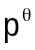 | 1,013 x 10⁵ Pa
Molar gas volume at STP  Molêre gasvolume by STD | V_{m} | 22,4 dm³∙mol⁻¹
Standard temperature  Standaardtemperatuur | 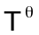 | 273 K
Charge on electron | e | -1,6 x 10⁻¹⁹ C
Avogadro’s’ number |  | 6,02×10²³

TABLE 2: FORMULAE/TABEL 2: FORMULES

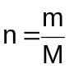 | 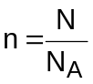
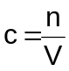 or 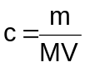 | 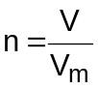
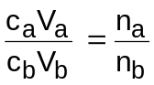 | pH = -log[H₃O⁺]
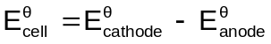 / 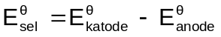

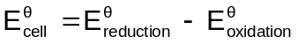 / 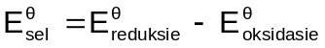

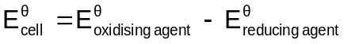 / 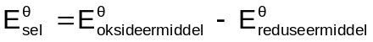

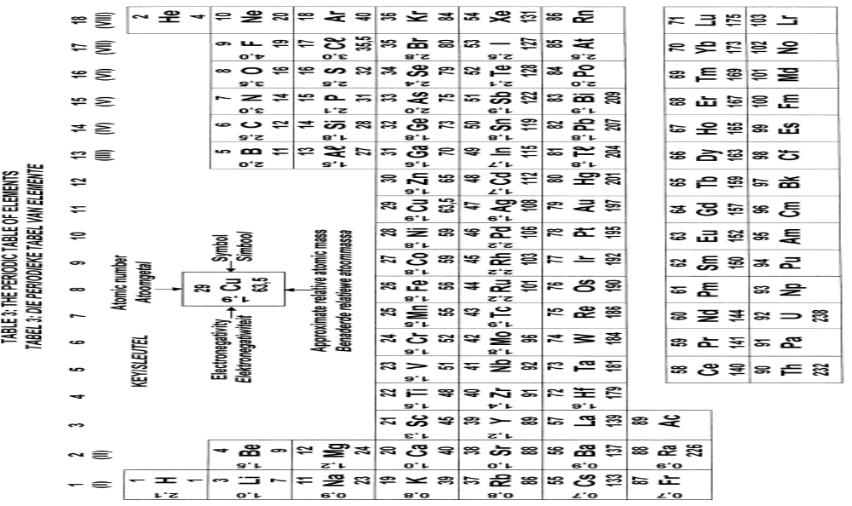

TABLE 4A: STANDARD REDUCTION POTENTIALS
TABEL 4A: STANDAARD REDUKSIEPOTENSIALE
Half-reactions/Halfreaksies |  |  | 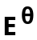 (V)
F₂(g) + 2e⁻ | ⇌ | 2F⁻ | + 2,87
Co³⁺ + e⁻ | ⇌ | Co²⁺ | + 1,81
H₂O₂ + 2H⁺ +2e⁻ | ⇌ | 2H₂O | +1,77
MnO + 8H⁺ + 5e⁻ | ⇌ | Mn²⁺ + 4H₂O | + 1,51
Cℓ₂(g) + 2e⁻ | ⇌ | 2Cℓ⁻ | + 1,36
Cr₂O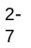 + 14H⁺ + 6e⁻ | ⇌ | 2Cr³⁺ + 7H₂O | + 1,33
O₂(g) + 4H⁺ + 4e⁻ | ⇌ | 2H₂O | + 1,23
MnO₂ + 4H⁺ + 2e⁻ | ⇌ | Mn²⁺ + 2H₂O | + 1,23
Pt²⁺ + 2e⁻  Increasing oxidising ability/Toenemende oksiderende vermoë | ⇌ | Pt | + 1,20  Increasing reducing ability/Toenemende reduserende vermoë
Br₂(ℓ) + 2e⁻ | ⇌ | 2Br⁻ | + 1,07
NO + 4H⁺ + 3e⁻ | ⇌ | NO(g) + 2H₂O | + 0,96
Hg²⁺ + 2e⁻ | ⇌ | Hg(ℓ) | + 0,85
Ag⁺ + e⁻ | ⇌ | Ag | + 0,80
NO + 2H⁺ + e⁻ | ⇌ | NO₂(g) + H₂O | + 0,80
Fe³⁺ + e⁻ | ⇌ | Fe²⁺ | + 0,77
O₂(g) + 2H⁺ + 2e⁻ | ⇌ | H₂O₂ | + 0,68
I₂ + 2e⁻ | ⇌ | 2I⁻ | + 0,54
Cu⁺ + e⁻ | ⇌ | Cu | + 0,52
SO₂ + 4H⁺ + 4e⁻ | ⇌ | S + 2H₂O | + 0,45
2H₂O + O₂ + 4e⁻ | ⇌ | 4OH⁻ | + 0,40
Cu²⁺ + 2e⁻ | ⇌ | Cu | + 0,34
SO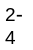 + 4H⁺ + 2e⁻ | ⇌ | SO₂(g) + 2H₂O | + 0,17
Cu²⁺ + e⁻ | ⇌ | Cu⁺ | + 0,16
Sn⁴⁺ + 2e⁻ | ⇌ | Sn²⁺ | + 0,15
S + 2H⁺ + 2e⁻ | ⇌ | H₂S(g) | + 0,14
2H⁺ + 2e⁻ | ⇌ | H₂(g) | 0,00
Fe³⁺ + 3e⁻ | ⇌ | Fe | − 0,06
Pb²⁺ + 2e⁻ | ⇌ | Pb | − 0,13
Sn²⁺ + 2e⁻ | ⇌ | Sn | − 0,14
Ni²⁺ + 2e⁻ | ⇌ | Ni | − 0,27
Co²⁺ + 2e⁻ | ⇌ | Co | − 0,28
Cd²⁺ + 2e⁻ | ⇌ | Cd | − 0,40
Cr³⁺ + e⁻ | ⇌ | Cr²⁺ | − 0,41
Fe²⁺ + 2e⁻ | ⇌ | Fe | − 0,44
Cr³⁺ + 3e⁻ | ⇌ | Cr | − 0,74
Zn²⁺ + 2e⁻ | ⇌ | Zn | − 0,76
2H₂O + 2e⁻ | ⇌ | H₂(g) + 2OH⁻ | − 0,83
Cr²⁺ + 2e⁻ | ⇌ | Cr | − 0,91
Mn²⁺ + 2e⁻ | ⇌ | Mn | − 1,18
Aℓ³⁺ + 3e⁻ | ⇌ | Aℓ | − 1,66
Mg²⁺ + 2e⁻ | ⇌ | Mg | − 2,36
Na⁺ + e⁻ | ⇌ | Na | − 2,71
Ca²⁺ + 2e⁻ | ⇌ | Ca | − 2,87
Sr²⁺ + 2e⁻ | ⇌ | Sr | − 2,89
Ba²⁺ + 2e⁻ | ⇌ | Ba | − 2,90
Cs⁺ + e⁻ | ⇌ | Cs | – 2,92
K⁺ + e⁻ | ⇌ | K | − 2,93
Li⁺ + e⁻ | ⇌ | Li | − 3,05

TABLE 4B: STANDARD REDUCTION POTENTIALS
TABEL 4B: STANDAARD REDUKSIEPOTENSIALE

Increasing oxidising ability/Toenemende oksiderende vermoë
Increasing reducing ability/Toenemende reduserende vermoë
Half-reactions/Halfreaksies |  |  | (V)
Li⁺ + e⁻ | ⇌ | Li | − 3,05
K⁺ + e⁻ | ⇌ | K | − 2,93
Cs⁺ + e⁻ | ⇌ | Cs | − 2,92
Ba²⁺ + 2e⁻ | ⇌ | Ba | − 2,90
Sr²⁺ + 2e⁻ | ⇌ | Sr | − 2,89
Ca²⁺ + 2e⁻ | ⇌ | Ca | − 2,87
Na⁺ + e⁻ | ⇌ | Na | − 2,71
Mg²⁺ + 2e⁻ | ⇌ | Mg | − 2,36
Aℓ³⁺ + 3e⁻ | ⇌ | Aℓ | − 1,66
Mn²⁺ + 2e⁻ | ⇌ | Mn | − 1,18
Cr²⁺ + 2e⁻ | ⇌ | Cr | − 0,91
2H₂O + 2e⁻ | ⇌ | H₂(g) + 2OH⁻ | − 0,83
Zn²⁺ + 2e⁻ | ⇌ | Zn | − 0,76
Cr³⁺ + 3e⁻ | ⇌ | Cr | − 0,74
Fe²⁺ + 2e⁻ | ⇌ | Fe | − 0,44
Cr³⁺ + e⁻ | ⇌ | Cr²⁺ | − 0,41
Cd²⁺ + 2e⁻ | ⇌ | Cd | − 0,40
Co²⁺ + 2e⁻ | ⇌ | Co | − 0,28
Ni²⁺ + 2e⁻ | ⇌ | Ni | − 0,27
Sn²⁺ + 2e⁻ | ⇌ | Sn | − 0,14
Pb²⁺ + 2e⁻ | ⇌ | Pb | − 0,13
Fe³⁺ + 3e⁻ | ⇌ | Fe | − 0,06
2H⁺ + 2e⁻ | ⇌ | H₂(g) | 0,00
S + 2H⁺ + 2e⁻ | ⇌ | H₂S(g) | + 0,14
Sn⁴⁺ + 2e⁻ | ⇌ | Sn²⁺ | + 0,15
Cu²⁺ + e⁻ | ⇌ | Cu⁺ | + 0,16
SO + 4H⁺ + 2e⁻ | ⇌ | SO₂(g) + 2H₂O | + 0,17
Cu²⁺ + 2e⁻ | ⇌ | Cu | + 0,34
2H₂O + O₂ + 4e⁻ | ⇌ | 4OH⁻ | + 0,40
SO₂ + 4H⁺ + 4e⁻ | ⇌ | S + 2H₂O | + 0,45
Cu⁺ + e⁻ | ⇌ | Cu | + 0,52
I₂ + 2e⁻ | ⇌ | 2I⁻ | + 0,54
O₂(g) + 2H⁺ + 2e⁻ | ⇌ | H₂O₂ | + 0,68
Fe³⁺ + e⁻ | ⇌ | Fe²⁺ | + 0,77
NO + 2H⁺ + e⁻ | ⇌ | NO₂(g) + H₂O | + 0,80
Ag⁺ + e⁻ | ⇌ | Ag | + 0,80
Hg²⁺ + 2e⁻ | ⇌ | Hg(ℓ) | + 0,85
NO + 4H⁺ + 3e⁻ | ⇌ | NO(g) + 2H₂O | + 0,96
Br₂(ℓ) + 2e⁻ | ⇌ | 2Br⁻ | + 1,07
Pt²⁺ + 2 e⁻ | ⇌ | Pt | + 1,20
MnO₂ + 4H⁺ + 2e⁻ | ⇌ | Mn²⁺ + 2H₂O | + 1,23
O₂(g) + 4H⁺ + 4e⁻ | ⇌ | 2H₂O | + 1,23
Cr₂O + 14H⁺ + 6e⁻ | ⇌ | 2Cr³⁺ + 7H₂O | + 1,33
Cℓ₂(g) + 2e⁻ | ⇌ | 2Cℓ⁻ | + 1,36
MnO + 8H⁺ + 5e⁻ | ⇌ | Mn²⁺ + 4H₂O | + 1,51
H₂O₂ + 2H⁺ +2 e⁻ | ⇌ | 2H₂O | +1,77
Co³⁺ + e⁻ | ⇌ | Co²⁺ | + 1,81
F₂(g) + 2e⁻ | ⇌ | 2F⁻ | + 2,87

